On the possibility to observe a heavy Higgs via H⁰ → Z⁰Z⁰ → llνν decays at CMS

L.G. Levchuk, D.V. Soroka, P.V. Sorokin, M.V. Voronko, S.S. Zub

National Science Center “Kharkov Institute of Physics and Technology”, Kharkov, Ukraine
e-mail: voronko_max@kipt.kharkov.ua

A possibility to observe with the CMS a heavy (M_{H}  200 GeV/c²) Higgs decaying via H⁰ → Z⁰Z⁰ → llνν is studied. It is suggested that for Higgs masses close to threshold of H⁰ decay to the Z⁰Z⁰ pair. The “irreducible” background due to non-resonance production of weak boson pairs can be eliminated by a proper choice of event selection criteria leading to signature “l⁺l– + E_{T}^{miss}+ jets”. This observation is illustrated by PYTHIA/CMSJET simulations. For suppression of the Z+jets and tt contributions to the background, two sets of kinematics cuts are considered.

PACS: 13.87.Ce, 13.38.Dg, 14.80.Bn

1. INTRODUCTION
Collaborations performing experiments at LEP II have set [1] a fairly high (about 95%) confidence level (CL) for the Higgs mass M_{H} to be above 114 GeV/c², and no Higgs signal candidates have been reported by now from the Tevatron Run II. A new era for the Higgs physics will open out with putting the Large Hadron Collider (LHC) into operation in 2007. The new experimental facilities such the CMS have to enable extension of searches for the Higgs boson to the whole reasonable range (up to 1 TeV/c²) of its masses. Then, a failure to find the Standard Model (SM) Higgs in the measurements could result in changing the current understanding of the physics underlying generation of masses of known elementary particles. However, to have enough grounds for such a conclusion, one needs, of course, in addition to possessing detectors with excellent performances, a thorough examination of all possible mechanisms of Higgs production in pp collisions at the LHC energy, and all H⁰ decay modes allowing the produced Higgs boson of any plausible mass to emerge in measurements through clear and distinctive signatures.
On the other hand, the precision electroweak data (see Ref. [2]) appear to limit M_{H} from above with M_{H} < 195-230 GeV/c² at 95% CL. Though, as noted, e.g., in Ref. [3], the global fit to these data predicts for M_{H} a value which is far below 100 GeV/c² and practically excluded by the established in Ref. [1] lower constraint, M_{H} > 114 GeV/c². It may suggest [3] the existence of new physics beyond the SM that could be responsible for shifting M_{H} towards greater values and that was disregarded in the mentioned above analysis.
Our present consideration refers to studies of possibilities to observe with the CMS a heavy (M_{H}  200 GeV/c²) Higgs boson decaying to a couple of Z⁰ bosons with their subsequent decay to lepton (electron or muon) and neutrino pairs,

H⁰ → Z⁰Z⁰ → llνν. (1)

This decay mode, compared to the so-called “gold-plated” H⁰ → Z⁰Z⁰ → 4l channel, has about 6 times greater branching ratio and so, it may lead to a stronger signal at large M_{H} (when the Higgs production cross section is relatively small) with providing more opportunities to apply hard cuts for suppression of the background.
However, from a phenomenological point of view, decays (1) result in signatures of the “ll + E_{T}^{miss}” type, with ways of M_{H} reconstruction being not evident. As a consequence, observation of Higgs is thwarted a lot [4] by the “irreducible” background (IB) coming from non-resonance production of weak boson pairs (ZZ and ZW). The IB can emerge as the “ll + E_{T}^{miss}” signature with event distributions similar in their shape to those for the background. So, it turns out to be difficult to observe Higgs even in case of a substantial prevalence of the signal over the background.
The difficulties associated with registration at the CMS of a very heavy (M_{H} = 500÷1000 GeV/c²) Higgs particle via signature “ll + E_{T}^{miss}” were discussed in Ref. [4]. Here, we extend this study to the region of lower (M_{H} = 200÷250 GeV/c²) Higgs masses, which fits better the current status of the electroweak data, and show that the IB can be eliminated in this case.
2. ELIMINATION OF THE IB AND PYTHIA/CMSJET SIMULATIONS
For a moderately heavy (M_{H}  200 GeV/c²) Higgs particle with the mass exceeding the threshold of its decay to a couple of Z⁰ bosons only by ~ 10 GeV/c², the products of this decay should have a small relative momentum and preserve the direction of motion of the “mother” resonance H⁰. So, one may expect that for decay (1), the transverse momentum of the lepton pair P_{T}^{ll} and the missing transverse momentum P_{T}^{miss} would lie in the same semi-plane, with the angle between them being fairly small.
Quite a different picture manifests itself in case of the IB. The weak boson pairs are produced here in hard collisions of partons, and, therefore, gain on average momenta of opposite directions.
To have a quantitative illustration to this kinematic consideration, we have performed simulations exploiting PYTHIA (ver. 6.158) [5] as an event generator and the “fast” (non-GEANT) Monte-Carlo model CMSJET [6] (ver. 4.703) for the CMS response. To begin with, our event selection cuts were as follows

E_{T}^{miss} ≥ 60 GeV,
|η| ≤ 2.4,
P_{T}^{l} ≥ 20 GeV/c²,
P_{T}^{ll} ≥ 30 GeV/c²,
|M_{Z} – M_{ll}| ≤ 5 GeV/c²,
the number of high-P_{T} leptons ≡ 2. (2a)

The lepton transverse momentum P_{T}^{l} and pseudorapidity η cuts are determined here by the CMS physics properties and geometry (see, e.g., Ref. [7]). Comparatively hard cuts were set upon the missing transverse energy E_{T}^{miss} and transverse momentum of the detected ll pair P_{T}^{ll} in order to suppress the background due to single Z⁰ production accompanied by jets, “Z+jets”. Also, a rather narrow, compared to the “customary” choice of 6 GeV/c² [7], window has been established for the ll invariant mass to be in the vicinity of the Z⁰ mass M_{Z}, with the purpose of having the tt background at a lower level.
With these cuts, we have obtained for the event distributions over cos(∠P_{T}^{ll}P_{T}^{miss}) the plot displayed in Fig. 1. It is seen that by applying an appropriate cut (like the one shown by the arrows at ∠P_{T}^{ll}P_{T}^{miss} < 90°) the IB coming from the non-resonance Z⁰Z⁰ production can be washed out. This cut would eliminate also the Z⁰W± component of the background, since we have got in this case the cos(∠P_{T}^{ll}P_{T}^{miss}) distribution practically identical to the one for Z⁰Z⁰.
Then, it follows from Fig. 1 that for a considerable amount of the 200 GeV/c² Higgs signal events, vectors P_{T}^{ll} and P_{T}^{miss} still have opposite directions. These events correspond to low-P_{T} H⁰ production. In spite of the fact that they are effectively suppressed by cuts (2a), such events emerge here due to the essentially greater cross section compared to that for high-P_{T} H⁰ production.
It should be noted also that if condition ∠P_{T}^{ll}P_{T}^{miss} < 90° holds, the transverse momenta balance can only be provided by high-P_{T} jets. In other words, this criterion eliminating the IB selects events with, at least, one high-P_{T} jet. Furthermore, it turns out that modification of this cut to

∠P_{T}^{ll}P_{T}^{miss} < 90°,
∠P_{T}^{ll}P_{T}^{j} > 120°,
∠P_{T}^{miss}P_{T}^{j} > 120° (2b)

where P_{T}^{j} is the total transverse momentum of jets, does not result in any loss of the signal events, though may reduce the Z+jets and background.

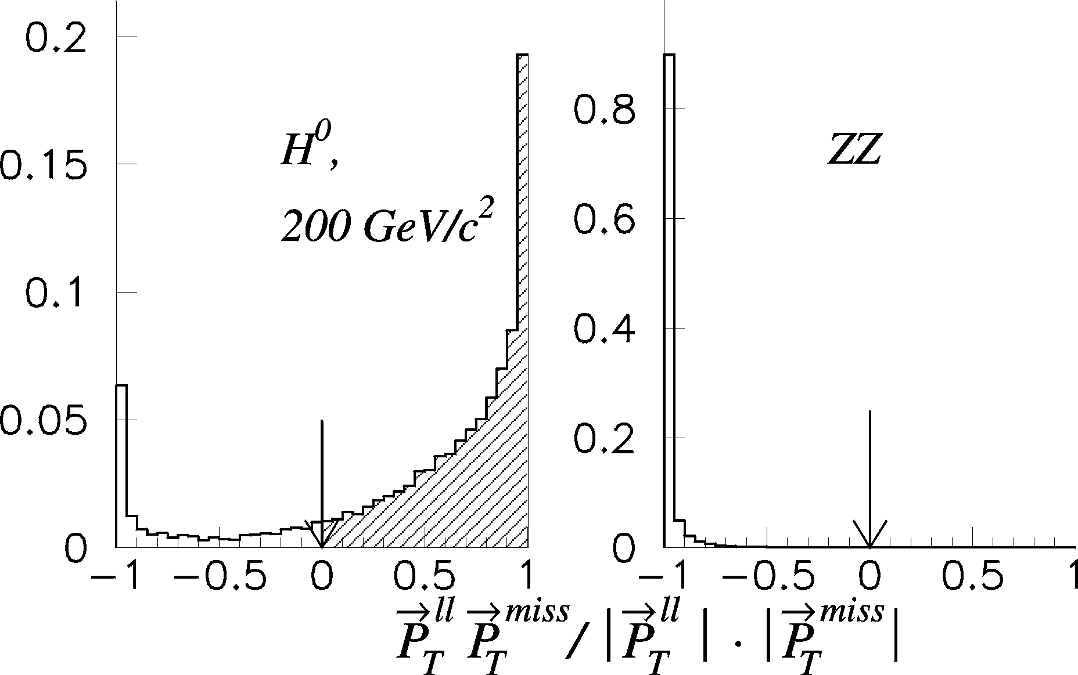
Fig. 1. Event distributions over angle between transverse momentum of the lepton pair and the missing transverse momentum for the 200 GeV/c² Higgs signal and non-resonance ZZ production

Apparently, the default PYTHIA option for Higgs production at the parton level, 2 → 1 gluon fusion gg → H⁰, is not a quite adequate tool for description of the process under consideration. It would provide jet formation occurring only through soft QCD processes, like initial- and final- state parton showers, with a tendency of underestimating the real yield of higt-P_{T} jets. So, we replaced in our simulations discussed below this option by the 2 → 2 hard processes gg → H⁰g and gq → H⁰q. The results are shown in Figs. 2 and 3. They were obtained with cuts (2a,b) supplemented by the requirement of having no b-jets with P_{T} > 40 GeV,

N_{b–jets} = 0 (2c)

that helps to suppress the background due to tt. As seen in Fig. 2, employing the 2 → 2 mechanisms of Higgs production instead of the 2 → 1 gluon fusion (of course, in the both cases, the 2 → 3 weak boson fusion mechanism qq → H⁰qq is also switched on.) leads to a considerable (by factor of ~ 1.5) signal enhancement.
This figure also displays the sensitivity of the event distributions to M_{H}. In a non-relativistic case, the quantity |P_{T}^{ll} – P_{T}^{miss}| would be a reasonable measure for the Higgs mass excess over 2M_{Z}. Then, one may hope (at least, for M_{H} very close to the H⁰ → Z⁰Z⁰ decay threshold) that the relation of this quantity to the ZZ pair c.m. momentum P_{Z} is preserved to some extent in the real situation. We see, however, that already for M_{H} ~ 250 GeV/c² the distributions are smeared by relativistic broadening. In addition, cuts (2b) prove to be too hard at M_{H}  250 GeV/c², so that few Higgs events survive them.

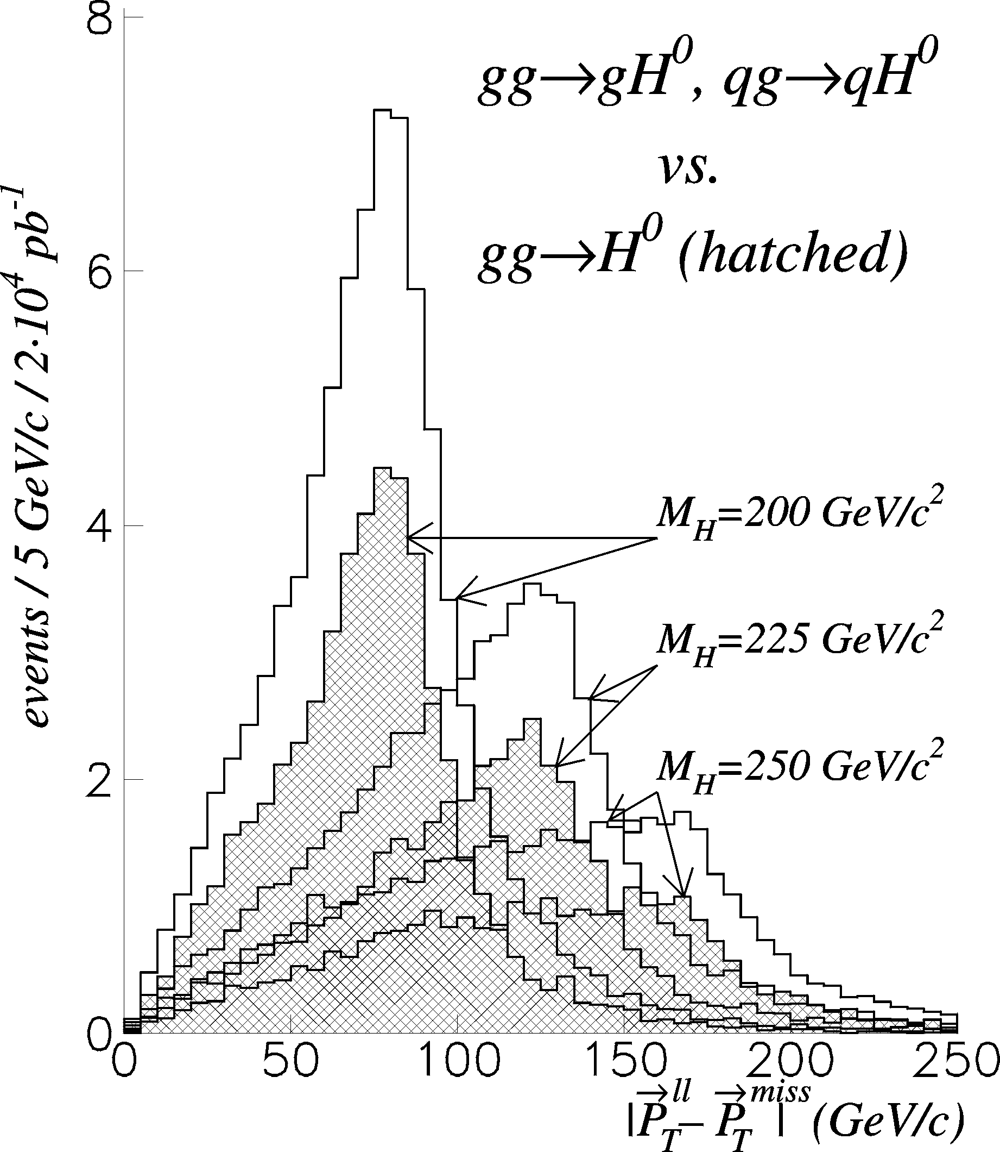
Fig. 2. Higgs signal simulated with 2 → 2 PYTHIA option for H⁰ production (open histogram) compared to that given by the “gluon fusion” 2 → 1 mechanism (hatched histograms)

Thus, with cuts (2), the background is completely determined by Z+jets and tt contributions. However, it is still fairly large compared to the signal (see Fig. 3). A way of background reduction with applying some extra selection criteria is considered in the next Section.

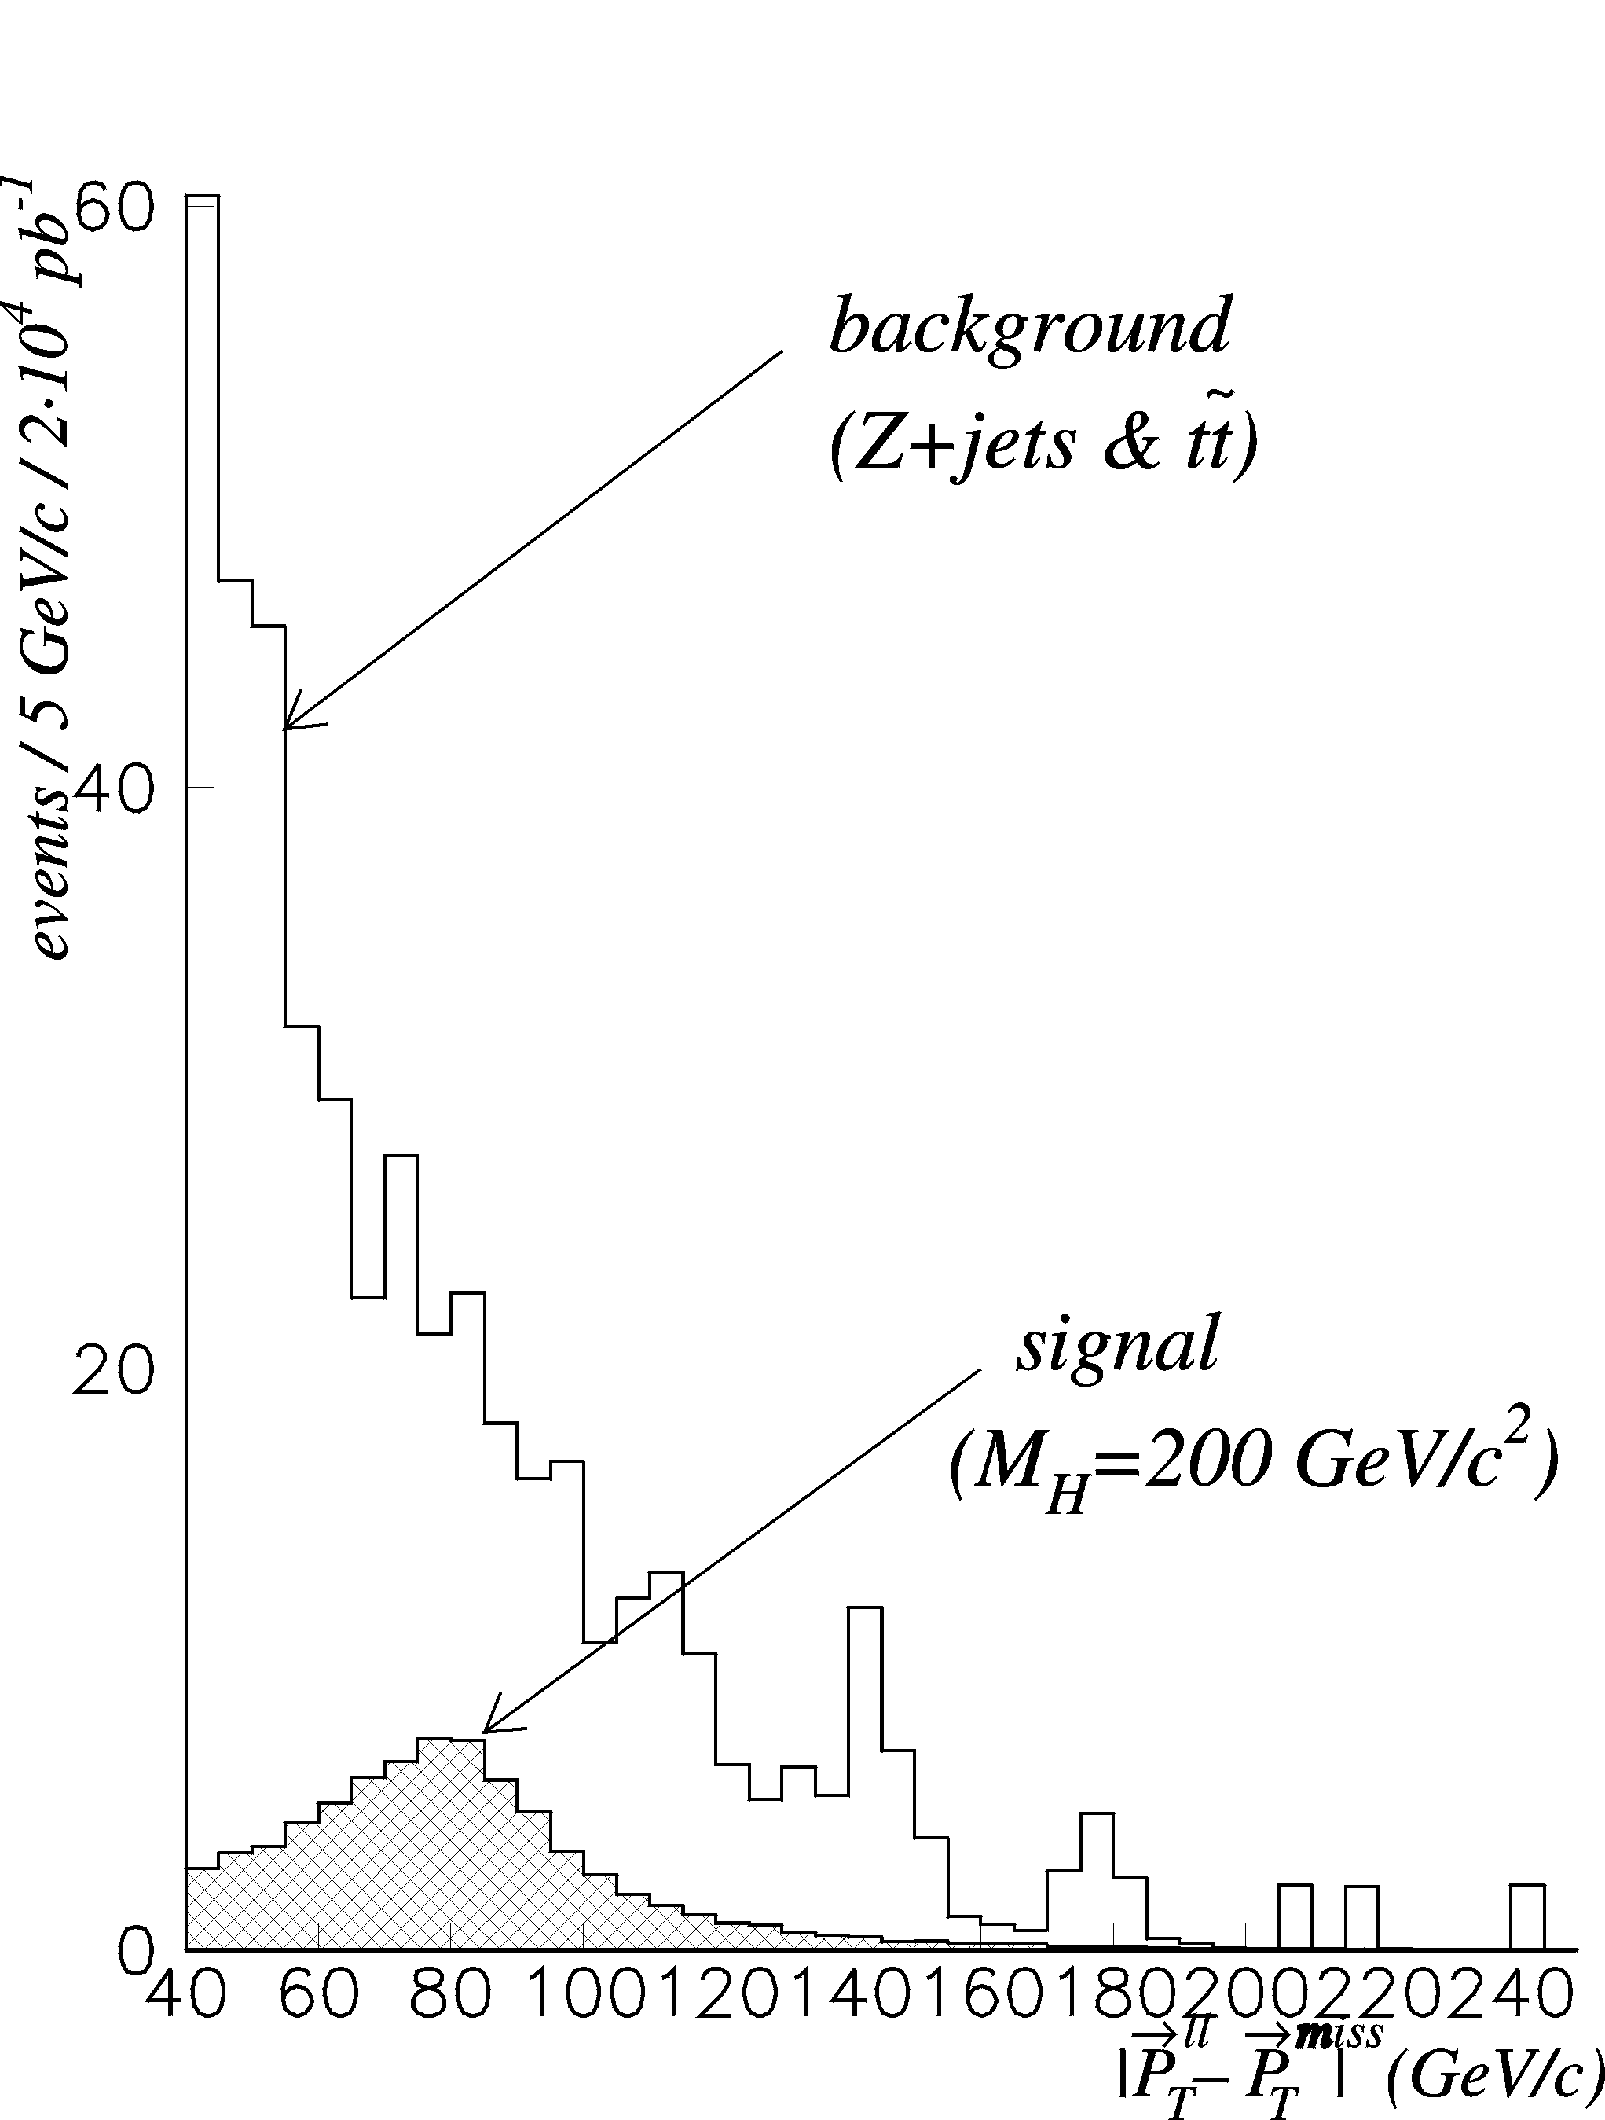
Fig. 3. Distributions of Higgs signal and background events over |P_{T}^{ll} – P_{T}^{miss}| for cuts (2)
3. SUPPRESSION OF THE Z+jets AND tt BACKGROUND AND DISCUSSION OF THE RESULTS
In order to have more events to play with, we may loosen the cut on E_{T}^{miss}, E_{T}^{miss} > 40 GeV, keeping all other conditions (2a,b,c) unchanged. Below, we will refer to this set of cuts as “A”. With these cuts, we have obtained the event rates listed in column “A” of the table.

Results of simulation
Channel (pp,  = 14 TeV) | event rates / 10⁵ pb⁻¹
 | A | B | C
H⁰ → Z⁰Z⁰ → llνν, M_{H} = 200 GeV/c² | 541 | 256 | 108
H⁰ → Z⁰Z⁰ → l⁺l–νν, M_{H} = 225 GeV/c² | 274 | 103 | 53
H⁰ → Z⁰Z⁰ → l⁺l–νν, M_{H} = 250 GeV/c² | 163 | 54 | 32
Z+jets → l⁺l– + jets | 5390 | 921 | 469
→ WW + jets → lνl⁺ν | 2118 | 1230 | 368
ZZ → llνν | 2.8 | 2.0 | 1.8
ZW → llνν | 5.9 | 3.8 | 2.3
Total background | 7508 | 2151 | 837

Then, let us consider the Higgs and Z+jets event distributions over the angle between the lepton momenta (see Fig. 4). A possibility to suppress the Z+jets contribution to the background can stem from a qualitative difference between these distributions (cf. Ref. [4]). The neutral weak bosons from decays of the Higgs with M_{H}  200 GeV/c² are, on average, less energetic than those produced directly in hard parton collisions, and, therefore, their decays to lepton pairs give rise to the considerably broader distribution over the lepton momenta relative angle. The spin correlations due to the scalar Higgs decay to the two vector bosons also may influence the shape of distributions shown in Fig. 4 for the H⁰ signal. One can see that the cuts set on angles between the lepton total and transverse momenta,

∠P^{l1}P^{l2} > 60°,
∠P_{T}^{l1}P_{T}^{l2} > 90° (3)

reduce the Z+jets background to a substantially greater extent than the H⁰ signal. The corresponding event rates are presented in column “B” of the table.

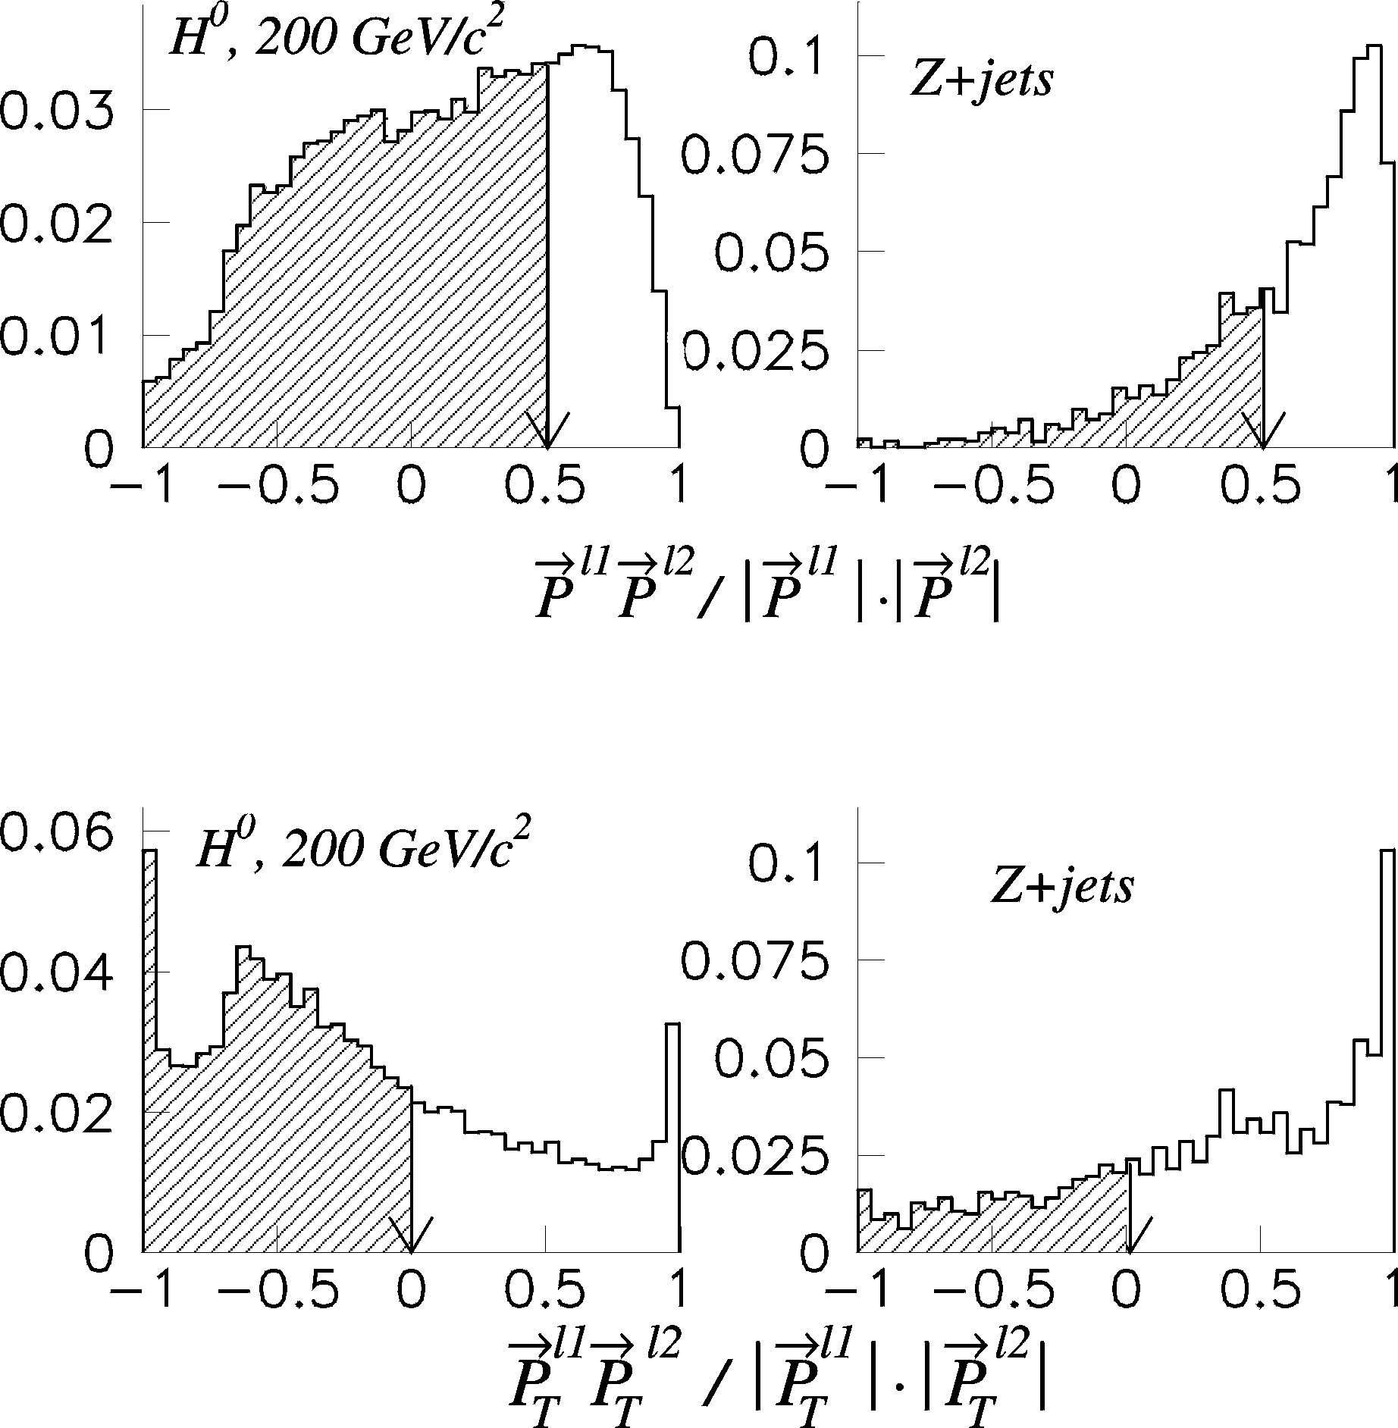
Fig. 4. Distributions of Higgs signal and Z+jets background events over angles between lepton total (top histogram) and transverse (bottom histograms) momenta

Unfortunately, the constraints (3) are not capable of an essential decrease of the tt background. To suppress the tt contribution, we have resorted to analysis of jet pseudorapidity distributions, which turn out to be significantly broader for the Higgs signal than for the tt events (see Fig. 5). It suggests applications of cuts on jet pseudorapidities η^{j} as follows

1.0 < |η^{j}| < 4.5. (4a)

In addition, to be tuned better to the 2 → 2 mechanisms of Higgs production by partons, gg → H⁰g and gq → H⁰q, we select only single-jet events,

N^{j} = 1, P_{T}^{j} > 40 GeV/c. (4b)

.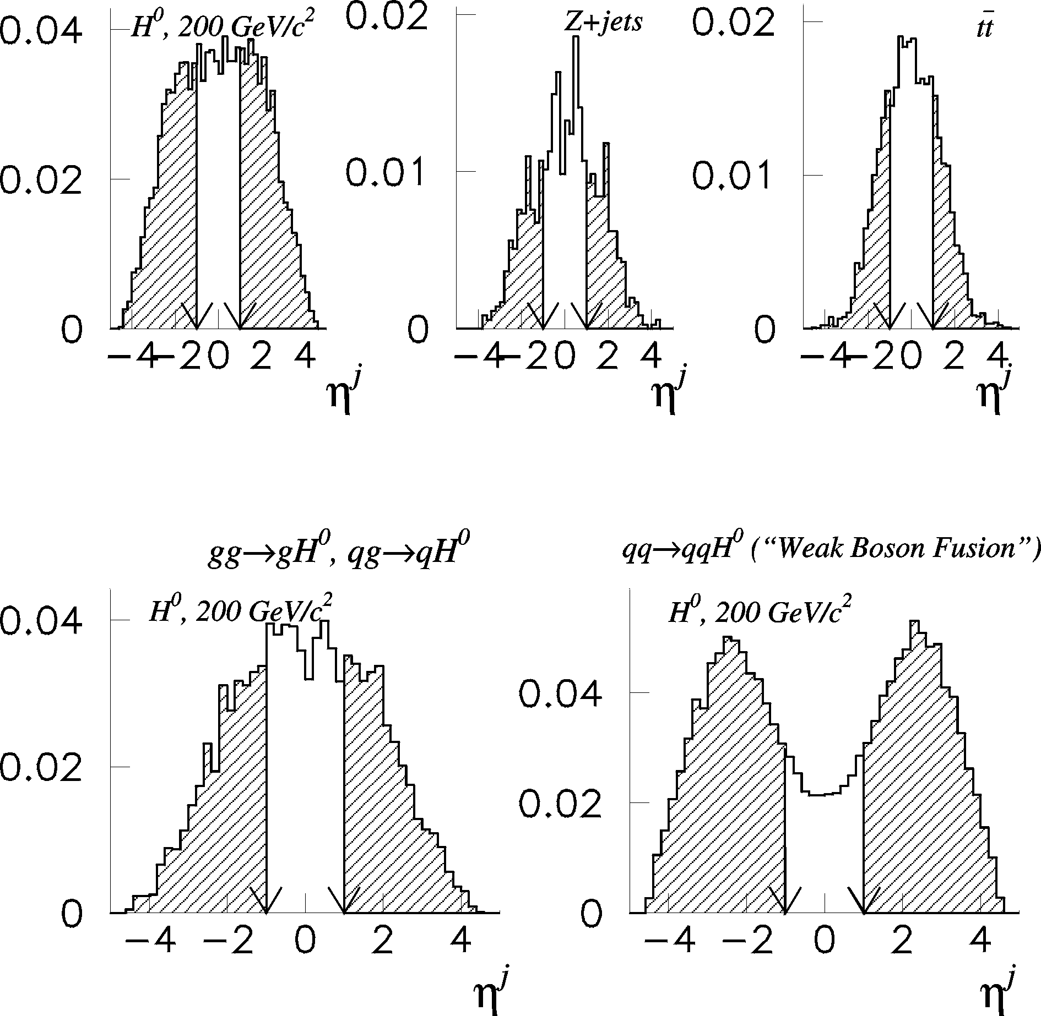

Fig. 5. Jet pseudorapidity distributions for Higgs signal and background events (three top histograms); comparison of jets pseudorapidity distribution in case of the 2 → 2 mechanism of Higgs production with that given by the WBF (two bottom histograms)

With imposing extra restrictions (4a,b), our final results are shown in column “C” of the table and Fig. 6. Cuts (3) and (4) result in a considerable, by the order of magnitude, suppression of the total Z+jets and tt background. However, Higgs signal reduction is also significant (by factor of ~5). Thus, the cuts considered here is an alternative to the ones discussed in Sect. 2 and lead to relatively small event rates (cf. Figs. 3 and 6). As follows from Fig. 6, the Higgs signal still appears to be small to be separated from the background. In addition, the cuts result in the signal prevalence over the IB being not so convincing as that provided by the criteria (2) or “A” (see the table). So, it would be desirable to check the IB suppression here by generation of the ZZ+jets and ZW+jets events through 2 → 3 parton interactions.

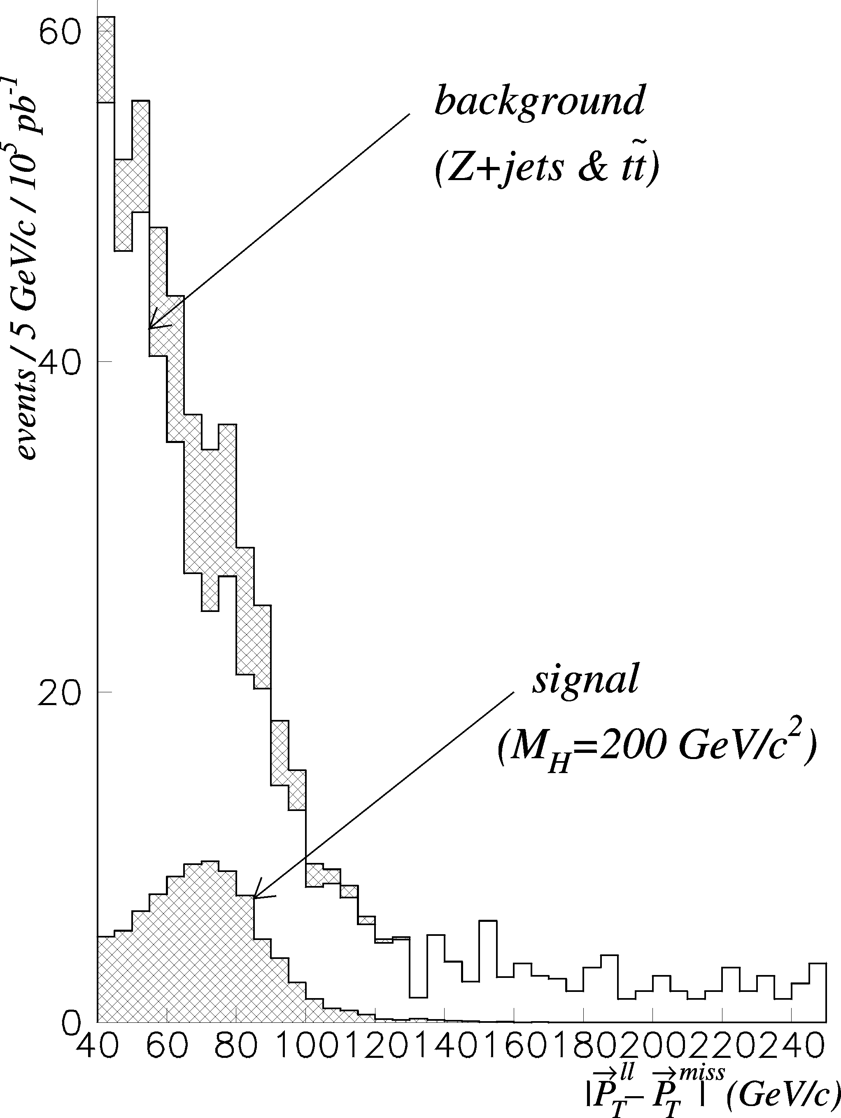
Fig. 6. Distributions of Higgs signal and background events over |P_{T}^{ll} – P_{T}^{miss}| fo cuts “A” supplemented by conditions (3) and (4)

However, supplementing the set of cuts “A” with conditions (3) and (4) may seem to be too restrictive, since, e.g., selection (4b) practically excludes events with the weak boson fusion (WBF) mechanism of H₀ production (see the left graph of Fig. 7). The WBF Higgs production yields a signature with two high-P_{T} jets in opposite directions (see, e.g., Ref. [8]). The comparison of η^{j} distributions for such events with those in case of gg → gH⁰ and qg → qH⁰ mechanisms is presented in Fig. 5. Evidently, the WBF events quite fit selection criterion (4a). Therefore, the hard cuts discussed here can be considered as a starting point that might be extended by adjusting them also to the 2-jet processes of Higgs production. Apart from the WBF, the latter include the QCD 2 → 3 H⁰ production mechanisms (a graph for one of them is shown in Fig. 7), the importance of which was pointed out, in particular, in Ref. [9]. Of course, some of the 2 → 3 QCD processes are effectively taken into account by the initial- and final-state gluon radiation corrections to the considered above 2 → 2 H⁰ production. However, such a treatment is not complete. Moreover, generation of dijet events via the PYTHIA initial- and final-state parton showers option as a soft-QCD correction to reactions gg → gH⁰ and qg → qH⁰ may be inadequate in case of high-P_{T} jets (cf. discussion in Sect. 2). So, in order to accomplish the adjustment of our selection criteria to the “H⁰ + 2jets” events, we have to perform simulations based on a more complicated generator, which would generate all the 2 → 3 mechanisms of Higgs production at the parton level. This work is currently under way.

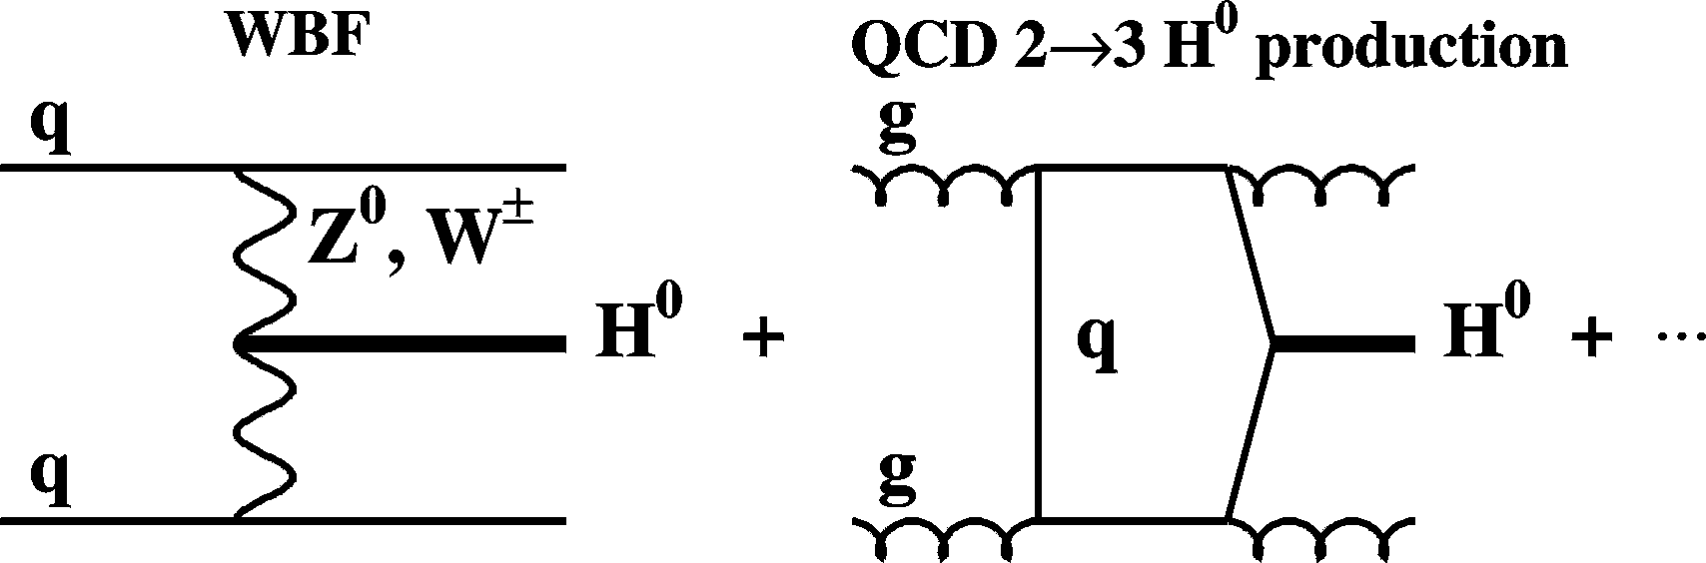
Fig. 7. WBF and QCD-based 2 → 3 mechanisms of Higgs production

CONCLUSIONS
A possibility to observe with the CMS a heavy (M_{H}  200 GeV/c²) Higgs decaying via (1) has been studied. It has been shown that for M_{H} values close to the threshold of H⁰ decay to the Z⁰Z⁰ pair, the “irreducible” background due to non-resonance production of weak boson pairs can be eliminated by a cut on the angle ∠P_{T}^{ll}P_{T}^{miss}. This observation based on a simple kinematic consideration has been illustrated by simulations exploiting PYTHIA as an event generator and CMSJET as a CMS response model. Since such a criterion selects events with high-P_{T} jets, one may speak here about signature “ll + E_{T}^{miss} + jets” rather than “ll + E_{T}^{miss}”. Accordingly, the default PYTHIA option for H⁰ production at the parton level, 2 → 1 “gluon fusion”, is not quite adequate here. Instead, we employed in simulations the 2 → 2 gg → gH⁰ and qg → qH⁰ mechanisms of Higgs production and have obtained the signal enhancement by factor of ~1.5. In order to suppress the Z+jets and tt background to an admissible level, the two (“loose” and “hard”) sets of selection criteria have been considered. Despite the fact that these cuts still do not provide a good separation of the Higgs signal from the background, they can be considered as a promising starting point for further studies. To provide a more realistic predictions in case of the signature under consideration, these studies have to be based on a more complicated generator, which would generate all the 2 → 3 mechanisms of Higgs and ZZ/ZW production at the parton level.

REFERENCES
- LEP Higgs Working Group. Search for the Standard Model Higgs Boson at LEP. CERN-EP/2001-055.
- G. Degrassi. hep-ph/0102137; J. Erler. hep-ph/0102143; ALEPH, DELPHI, L3 and OPAL Collaborations, LEP Higgs Working Group, and SLD Heavy Flavor and Electroweak Groups, D. Abbaneo et al.. hep-ex/0112021.
- M. Chanowitz. Electroweak Data and the Higgs boson mass: A case of new physics // Phys. Rev. D66 (2002) 073002.
- N. Stepanov. Search for heavy Higgs via the H → llνν channel. CMS-TN/93-087 (1993); N. Stepanov and S. Abdullin. Towards self-consistent scenario of the heavy Higgs observability via channels lνjj and llνν at CMS. CMS-TN/94-178 (1994); I. Gaines, D. Green, S. Kunori, J. Marrafino, J. Womersley, and W. Wu. Search for heavy Higgs in the channel H⁰ → Z⁰Z⁰ → llνν. CMS-TN/95-084 (1995).
- T. SjÖstrand. PYTHIA manual // Comp.Phys.Comm. 82 (1994) 74; CERN TH-6488/92 (1992).
- S. Abdullin, A. Khanov and N. Stepanov. CMSJET. CMS-TN/94-180 (1994).
- CMS Technical Proposal. CERN/LHCC 94-38, LHCC/P1 (1994).
- N. Akchurin, D. Green, S. Kunori, R. Vidal, W. Wu and M.T. Zeyrek. Study of low mass Higgs using pp → qqH at CMS. CMS Note 2002/016 (2002).
- V. Del Duca, W. Kilgore, C. Oleari, C. Schmidt, and D. Zeppenfeld. Production of a Higgs boson accompanied by two jets via gluon fusion // Phys. Rev. Lett 87 (2001) 122001.

О ВОЗМОЖНОСТИ ОБНАРУЖЕНИЯ В ДЕТЕКТОРЕ CMS ТЯЖЕЛОГО БОЗОНА ХИГГСА ПОСРЕДСТВОМ H⁰ → Z⁰Z⁰ → llνν РАСПАДОВ

М.В. Воронко, С.С. Зуб, Л.Г. Левчук, Д.В. Сорока, П.В. Сорокин
Изучена возможность обнаружения тяжелого бозона Хиггса посредством H⁰ → Z⁰Z⁰ → llνν распадов. Предполагалось, что масса частицы Хиггса близка к порогу распада на ZZ. Неприводимый фон, связанный с нерезонансным рождением векторных бозонов может быть подавлен путем выбора критериев отбора событий, которые приводят к сигнатуре сигнала “l⁺l– + E_{T}^{miss}+ jets”. Этот результат был проиллюстрирован с помощью PYTHIA/CMSJET моделирования. Рассмотрено два набора критериев отбора событий для подавления tt и Z+jets составляющих фона.

ЗНАХОДЖЕННЯ БОЗОНа ХІГСА в ДЕТЕКТОРІ CMS ЧЕРЕЗ РОЗПАДИ H⁰ → Z⁰Z⁰ → llνν

М.В. Воронко, С.С. Зуб, Л.Г. Левчук, Д.В. Сорока, П.В. Сорокін

Досліджено можливість знаходження важкого бозона Хіггса через розпади H⁰ → Z⁰Z⁰ → llνν. Припускалося, що маса частки Хіггса близька до порогу розпаду на ZZ. Неприводимий фон пов’язаний з нерезонансним народженням векторних бозонів може бути подавлений завдяки вибору критеріїв відбору подій, що ведуть до сигнатури сигналу “l⁺l– + E_{T}^{miss}+ jets”. Цей результат проілюстровано за допомогою PYTHIA/CMSJET моделювання. Розглянуто два набори критеріїв відбору подій для подавленя tt та Z+jets компонент фону.

